Task 2: JavaScript Mini Project – Web Calculator
Submitted By: Ganeshji Sahu
Project Overview
As part of the JavaScript Mini Project task, I developed a Web Calculator using HTML, CSS, and JavaScript. The calculator performs basic arithmetic operations and demonstrates DOM manipulation and event handling concepts.
Objectives
• Build an interactive web application using JavaScript.
• Understand DOM manipulation.
• Handle user interactions through button clicks.
• Create a simple and responsive user interface.
Technologies Used
• HTML5
• CSS3
• JavaScript
Features
• Addition
• Subtraction
• Multiplication
• Division
• Clear and Delete Functions
• Responsive Design
• DOM Manipulation
Project Working
The calculator accepts input through on-screen buttons. When a user clicks a button, JavaScript updates the display dynamically. Mathematical expressions are evaluated and the result is displayed instantly.
Hosted Project Link
https://web-calculator-basic.netlify.app/
GitHub Repository Link
https://github.com/Ganeshsahu09/Web-Calculator
Screenshots
- Calculator Home Screen
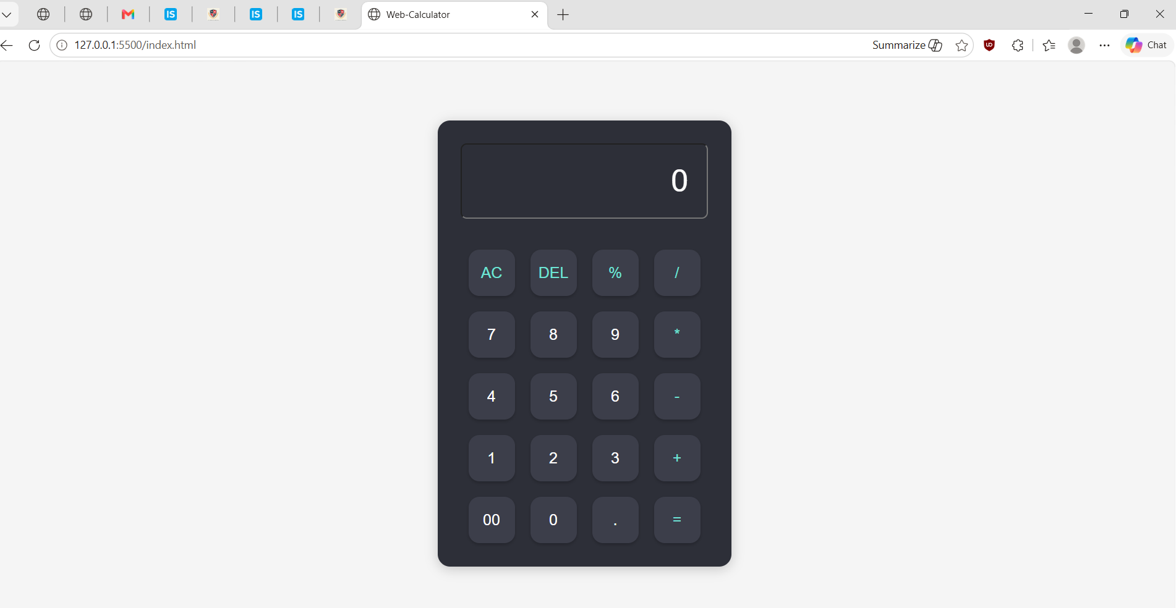
2. Performing a Calculation
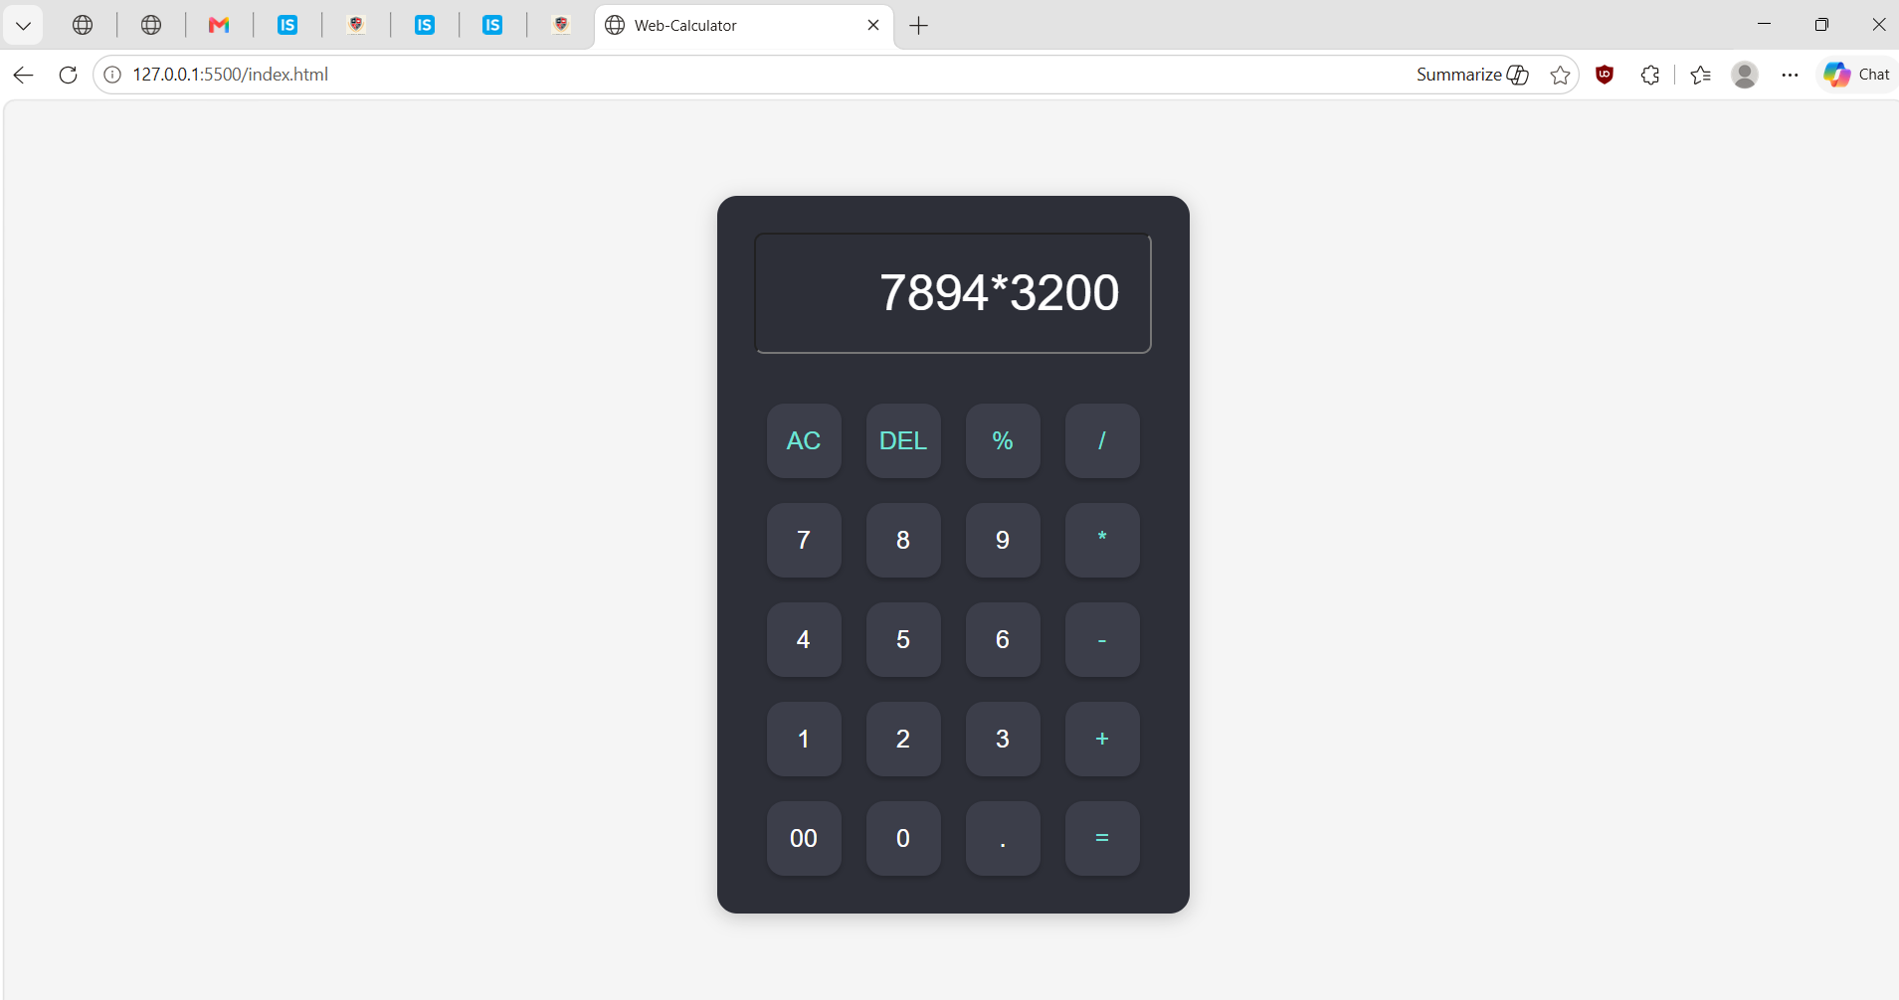
3. Mobile Responsive View
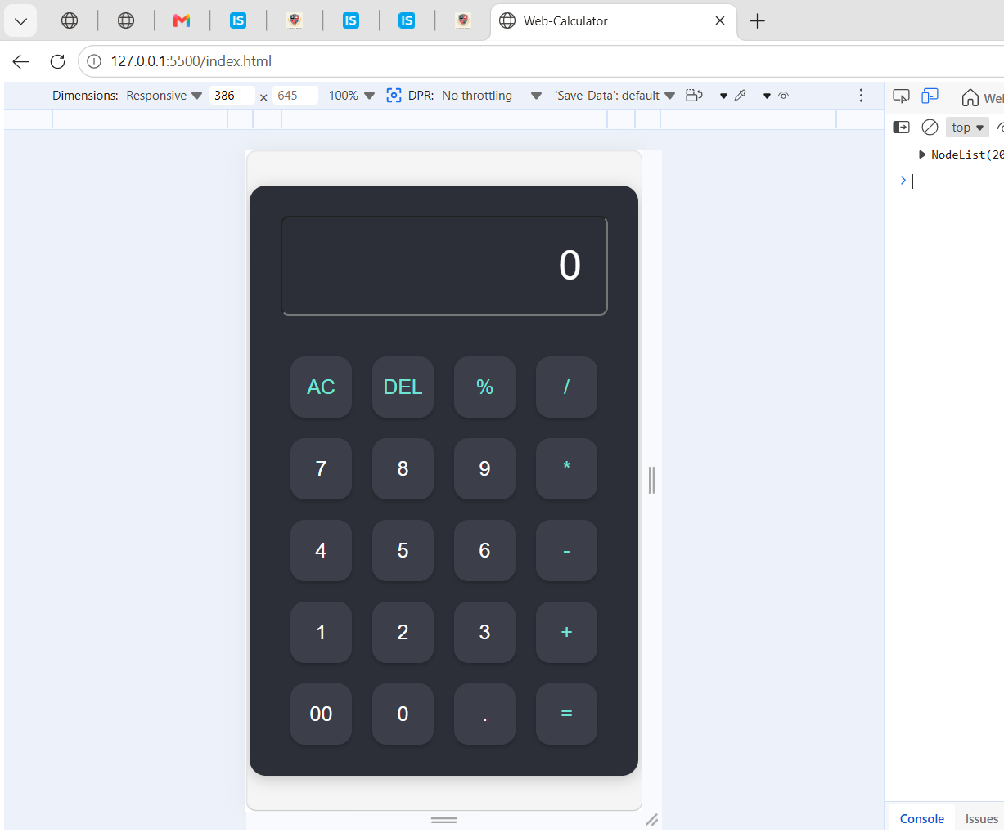
Sample Code Snippets
HTML:
<input type='text' id='display' readonly>
JavaScript:
function calculate() {
display.value = eval(display.value);
}
Learning Outcomes
• Improved JavaScript skills
• Learned DOM manipulation
• Practiced event handling
• Gained experience with GitHub and project deployment
Conclusion
This project helped me understand JavaScript, DOM manipulation, and front-end development concepts. It successfully meets the requirements of the JavaScript Mini Project task.

